Missing at Random (MAR) Analysis Report
Generated on: 2026-04-27 05:03:51
Dataset: 363,881 rows × 18 columns

1. Executive Summary
• Total missing values: 45,850 (0.70% of all data)
• Variables with missing data: 3 out of 18
• MAR supported for: 3 variables

2. Dataset Overview
Metric | Value
Number of Rows | 363,881
Number of Columns | 18
Total Missing Values | 45,850
Overall Missing Rate | 0.70%

3. Missing Data Summary
Variable | Data Type | Missing Count | Missing %
Birth_Weight(grams) | float64 | 45,303 | 12.45%
Race_of_Father | str | 531 | 0.15%
Birth_Order | str | 16 | 0.00%

4. Missing at Random (MAR) Analysis Results

4.1 Variable: Birth_Weight(grams)
Missing Statistics:
• Missing values: 45,303 (12.45%)
• Data type: float64
MAR Determination: YES - Missing at Random supported
Missingness in "Birth_Weight(grams)" is significantly associated with 4 other observed variable(s) in the dataset, satisfying the MAR condition.
- Associated Variables:
Associated Variable | Type | Statistical Test | P-value
Registered_Month2.0 | numerical | Mann-Whitney U | 0.0000
Registered_District_2.0 | numerical | Mann-Whitney U | 0.0000
Birh_Year | numerical | Mann-Whitney U | 0.0000
Age of Mother | numerical | Mann-Whitney U | 0.0040

4.2 Variable: Birth_Order
Missing Statistics:
• Missing values: 16 (0.00%)
• Data type: str
MAR Determination: YES - Missing at Random supported
Missingness in "Birth_Order" is significantly associated with 3 other observed variable(s) in the dataset, satisfying the MAR condition.
- Associated Variables:
Associated Variable | Type | Statistical Test | P-value
Registered_Month2.0 | numerical | Mann-Whitney U | 0.0011
Birh_Year | numerical | Mann-Whitney U | 0.0007
Age of Mother | numerical | Mann-Whitney U | 0.0000

4.3 Variable: Race_of_Father
Missing Statistics:
• Missing values: 531 (0.15%)
• Data type: str
MAR Determination: YES - Missing at Random supported
Missingness in "Race_of_Father" is significantly associated with 3 other observed variable(s) in the dataset, satisfying the MAR condition.
- Associated Variables:
Associated Variable | Type | Statistical Test | P-value
Registered_District_2.0 | numerical | Mann-Whitney U | 0.0008
Birh_Year | numerical | Mann-Whitney U | 0.0000
Age of Mother | numerical | Mann-Whitney U | 0.0000

5. Missing Data Visualizations
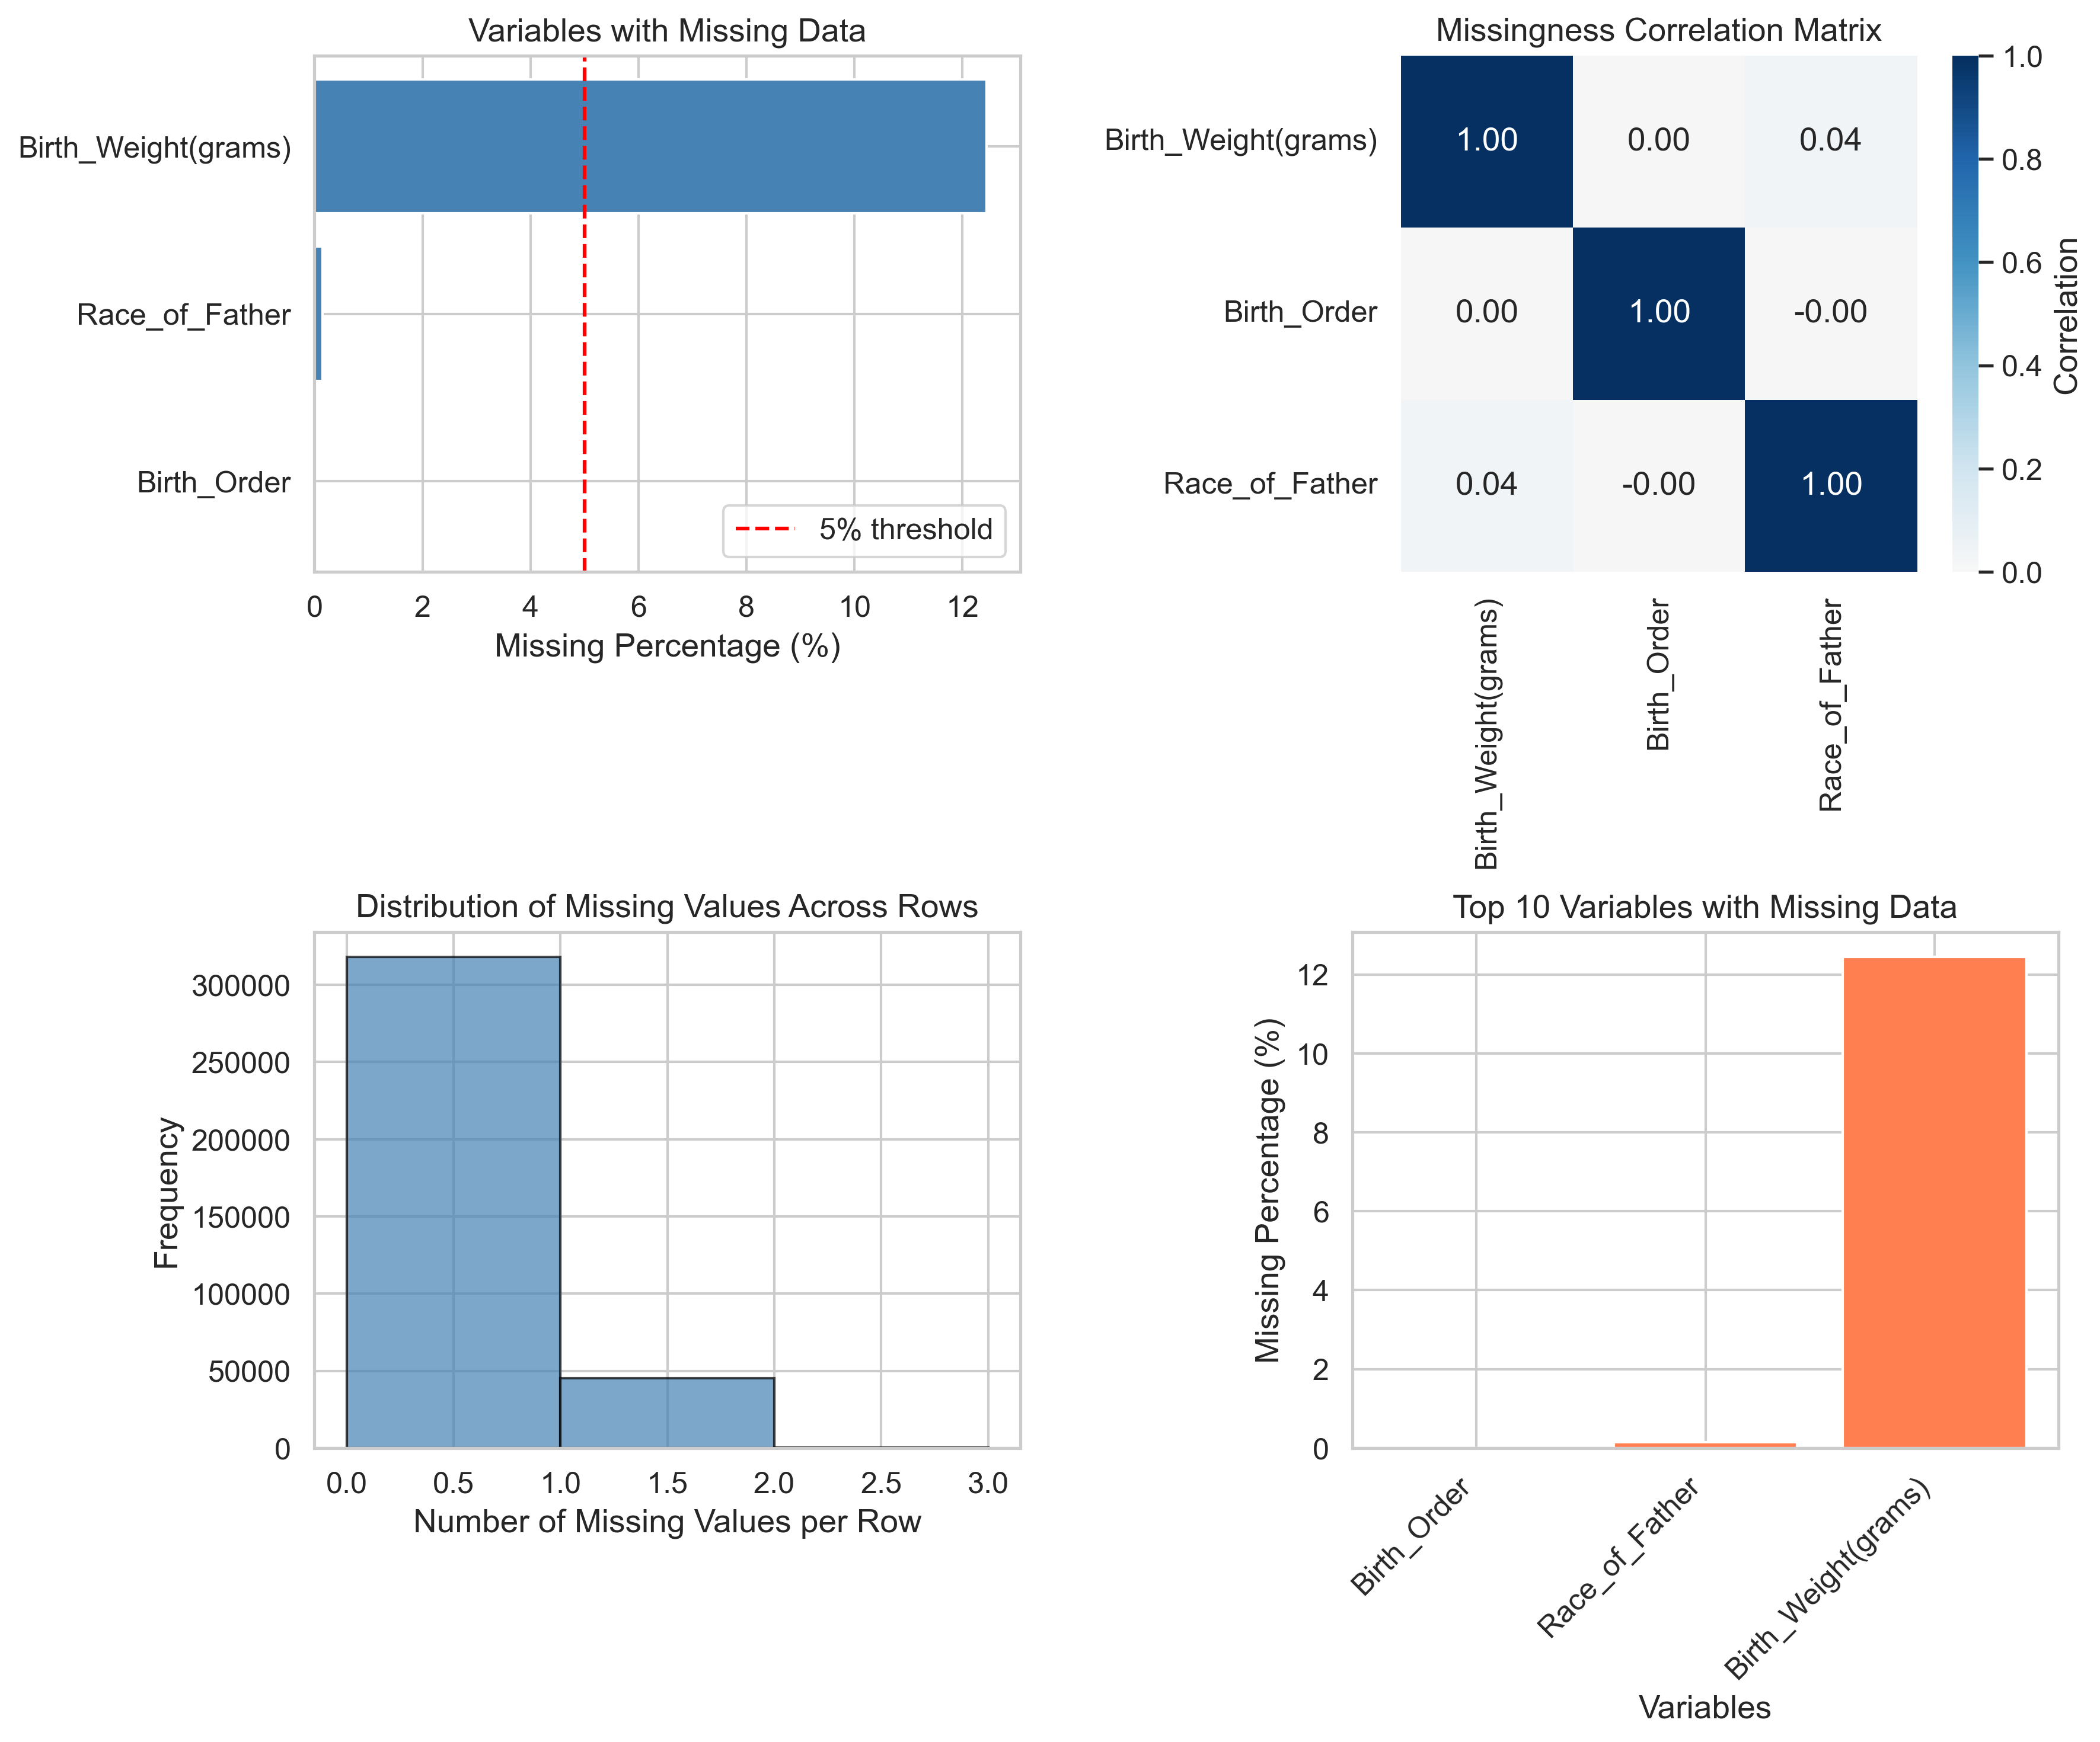
Figure 1: Missing Data Visualizations

6. Recommendations for Missing Data Handling

For MAR Variables:
- Since missingness in these variables depends on observed data, use:
- Multiple Imputation by Chained Equations (MICE)
- Full Information Maximum Likelihood (FIML)
- Expectation-Maximization (EM) Algorithm
Variables to impute: Birth_Weight(grams), Birth_Order, Race_of_Father

7. Conclusion
Based on the analysis, 3 out of 3 variable(s) with missing data demonstrate MAR patterns. This indicates that missingness is systematically related to observed variables, making multiple imputation an appropriate strategy.
Overall missing data rate is 0.70%, which is low and requires appropriate handling to avoid biased results.

8. Appendix: Detailed Statistics

Complete MAR Results
Variable | MAR Supported | Number of Associations
Birth_Weight(grams) | Yes | 4
Birth_Order | Yes | 3
Race_of_Father | Yes | 3

